Research Letter

Heart Rhythm Society’s survey assessing cardiac implantable electronic devices and magnetic resonance imaging

Christopher F. Liu, MD FHRS1

Kenneth A. Ellenbogen, MD FHRS2

Mina K. Chung, MD FHRS3

Andrew D. Krahn, MD FHRS4

Timothy R. Larsen, DO FHRS5

David J. Slotwiner, MD FHRS1

Mark H. Schoenfeld, MD FHRS6

Molly Sachdev, MD FHRS7

Sumeet K. Mainigi, MD FHRS8

Adam E. Berman, MD FHRS9

J. Peter Weiss, MD FHRS10

Amit J. Thosani, MD FHRS11

Scott J. Greenberg, MD, FHRS12

Jonathan W. Dukes, MD FHRS13

Arvindh N. Kanagasundram, MD FHRS14

Sabina Hadziabdulahovic, MSN, NP15

Lisa Miller, MS16

Anne Marie Smith, MBA, PMP16

Amit J. Shanker, MD FHRS17

1Weill Cornell Medical College, New York, NY

2Virginia Commonwealth University School of Medicine, Richmond, VA

3Cleveland Clinic, Cleveland, OH

4University of British Columbia, Vancouver, Canada

5Rush University Medical Center, Chicago, IL

6Yale University School of Medicine, New Haven, CT

7Washington University School of Medicine, St. Louis, MO

8Jefferson Einstein Hospital, Philadelphia, PA

9Baptist Medical Center, Jackson, MS

10University of Arizona – Banner, Phoenix, AZ

11Allegheny General Hospital, Pittsburgh, PA

12Baylor College of Medicine, Houston, TX

13,Community Memorial Health , CA

14Vanderbilt University Medical Center, Nashville, TN

15Cedars Sinai Medical Center, Los Angeles, CA

16Heart Rhythm Society, Washington, DC

17St. Lawrence Health System, Hellertown, PA

Word Count: max 800 (not including max 5 references)

Conflicts of interest:.

Correspondence:

Christopher F. Liu, MD FHRS

Weill Cornell Medicine – New York Presbyterian Hospital

Dept of Medicine – Cardiology

520 E. 70th St. Starr-4

New York, NY 10021

[CHL7001@med.cornell.edu](mailto:CHL7001@med.cornell.edu)

As the number of patients with cardiac implantable electronic devices (CIED’s) grows due to expanding indications and longer lifespans, real-world access to magnetic resonance imaging (MRI) in this population is garnering more intense interest. The 2017 HRS expert consensus statement described recommended protocols for scanning MR-conditional and non-MR-conditional CIED systems.1 In the United States, the Centers for Medicare and Medicaid Services (CMS) also expanded its coverage to include non-MR-conditional systems (“off-label MRI”) under certain conditions.2 However, availability and ease of MRI access for patients with CIED’s (especially non-MR-conditional systems) remain unclear. To inform advocacy efforts, HRS convened a Task Force to examine this issue, and the HRS Health Policy and Regulatory Affairs Committee (HPRAC) concurrently conducted a survey to gauge current status and opinions concerning MRI in CIED patients. In May 2024, the survey was distributed via e-mail and social media to HRS members and all attendees of the HRS Scientific Sessions. All responses were completed digitally.

Of 640 survey respondents who manage CIED patients, 478 (75%) were based in the US (55% physicians, 37% allied professionals), and 159 (25%) were from outside US (78% physicians, 16% allied professionals).

The full survey results are available at [https://www.hrsonline.org/guidance/health-policy](https://urldefense.com/v3/__https:/www.hrsonline.org/guidance/health-policy__;!!Aer6R9v1Nk4!7EGuykfaIzmUV9qumi3KB9qPSXIOAFQYCT2xPmEvD3MtL_dnX2JNF_lJabyVx9tE9O54CrpDXSloBvh04RjgtL09_DA$), with key responses summarized in **Figure 1**.

*Access and Workflow for MRI-Conditional & -Non-Conditional CIED’s*

For patients with MR-conditional systems, MRI access was routine (at home facility, <1 month wait) for 62% of respondents, whereas 24% reported a 1-3 month wait at their home facility and 14% reported >3 month wait or having to send patients elsewhere (<1% indicated MRI was not available at any nearby facility). The responses were similar for US and outside US.

For patients with non-MR-conditional systems, MRI access was routine (at home facility, <1 month wait) for only 21% of respondents, whereas 23% reported a 1-3 month wait at their home facility and a 56% majority reported >3 month wait or having to send patients elsewhere (17% indicated MRI was not available at any nearby facility). The responses were again similar for US and outside US, with the exception that more respondents from outside US indicated lack of MRI at any nearby facility.

Overall 70% respondents feel somewhat or generally comfortable with gauging MRI risk for non-conditional CIEDs. When asked about specific non-MR-conditional scenarios, a vast majority of respondents would approve MRI for mixed vendor systems with MR-conditional components, as well as for mix of conditional and non-conditional components, especially in non-pacing-dependent patients. The scenario of an MR-conditional system with another MR-conditional cardiac device would also be approved by 94%. Respondents expressed more caution for abandoned leads and epicardial leads (only 42% would sometimes or always approve).

With regard to MRI coordination, 69% of these EP clinicians are asked about MRI suitability at least once per week, which 79% find disruptive to their job workflow. Only 51% have a formal protocol at their local institution for scanning non-MR-conditional CIED; 74% have experienced inability to obtain an off-label MRI that was felt to be low risk. Overall 38% were dissatisfied with existing facility protocols for CIED MRI (including for conditional systems), and 45% feel their local MRI facility’s efforts to accommodate CIED patients for MRI are inadequate, resulting in 49% of respondents expressing that patient care is “often” or “very often” adversely affected by inability to obtain timely MRI in non-MR-conditional CIED patients. Coverage authorization denials have also led some to prefer to do off-label MRI as inpatient. However, 70% of respondents felt their device team’s work for the average non-conditional CIED patient to undergo MRI is either “somewhat” or “very excessive”, as seen in the 50% of respondents who estimate >30 minutes (27% estimate >60 minutes) dedicated by their device team to this type of MRI. Respondents clearly believe payment for EP services in support of MRI in CIED patients is inadequate (38%) or very inadequate (48%).

When asked about additional efforts to improve MRI access for CIED (especially non-conditional) patients, 90% felt that government regulatory agencies (like the US FDA and CMS) need to “moderately” or “significantly” increase their efforts, whereas a similar 83% felt so for CIED manufacturers and 92% felt so for MRI facilities. In fact, 72% of respondents felt that a CIED manufacturer with MR-conditional labeling for a mix of its generator and other manufacturers’ leads would gain a moderate or significant competitive advantage in their practice, and 95% of all respondents strongly believe updating MR-conditional labeling to mixed-brand systems is a medium or high priority task for industry and regulatory agencies (to be accomplished in <5 years). Many individual comments clamored for additional guidance for safety protocols and member engagement for registry tracking as well as sharing of protocols.

*Conclusion*

With inherent limitations of a voluntary survey, the results herein provide a basis for ongoing dialogue with the CIED industry, regulatory agencies, and radiologic societies and facilities as we advocate for expanding and facilitating CIED patients’ access to MRI while maintaining safety and managing resources. A task force has been formed with leadership from HRS and its HPRAC to devise a recommended path to engage with all stakeholders. Recognizing that radiology teams and facilities face their own challenges in resources and expertise, HRS remains ready to collaborate “to improve the care of patients by promoting research, education, and optimal health care policies and standards”. Stay informed of HPRAC advocacy efforts at <https://www.hrsonline.org/guidance/advocacy-in-action>.

**References**

1. Indik JH, Gimbel JR, Abe H, et al. 2017 HRS expert consensus statement on magnetic resonance imaging and radiation exposure in patients with cardiovascular implantable electronic devices. *Heart Rhythm.* 2017;14:e97–e153.
2. <https://www.cms.gov/medicare-coverage-database/view/ncacal-decision-memo.aspx?proposed=N&NCAId=289>

**Figure 1**

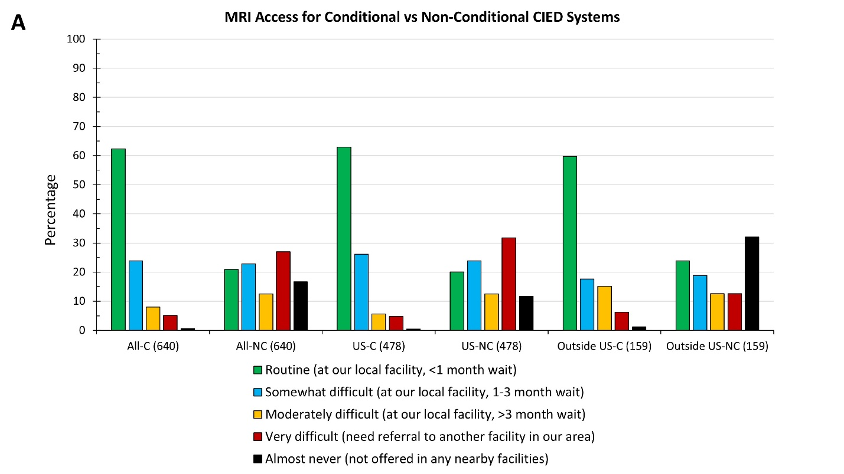

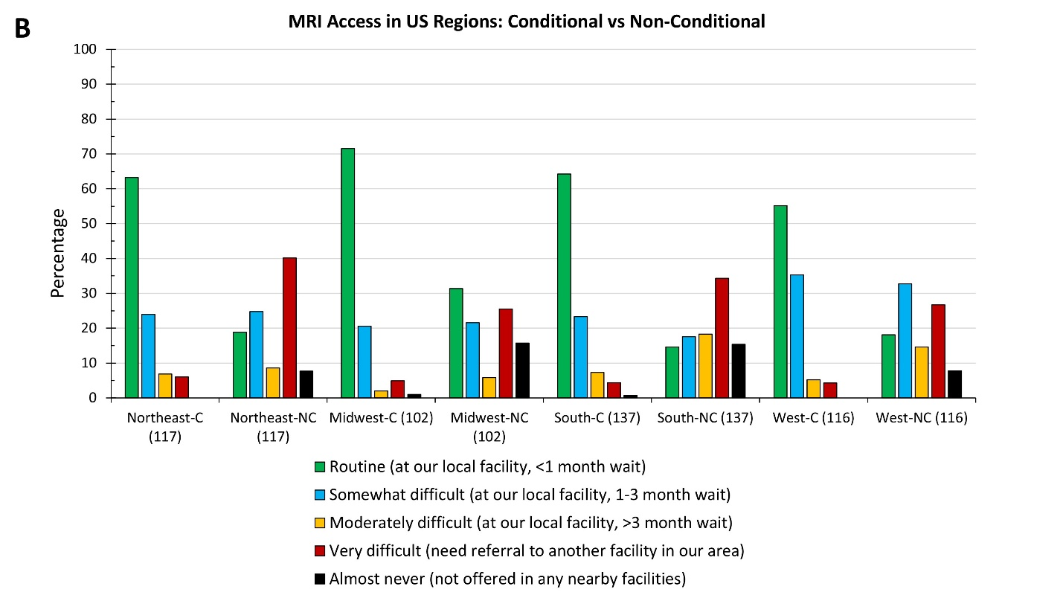

**Figure 1 Legend:**

Responses regarding MRI access. Total respondents for each group are in parentheses. CIED = cardiac implantable electronic device; C = conditional; NC = non-conditional.